Studıo bıllıon

ADB Screen Recorder – Editor
ADB Screen Recorder is a tool for record Android device screen via Android Debug Bridge (ADB)
Setup:
Import the package via Unity Asset Store.
Usage:

- Connect your Android device to PC via USB cable.
- Open Screen Record Window from StudioBillion->ADB Screen Recorder.
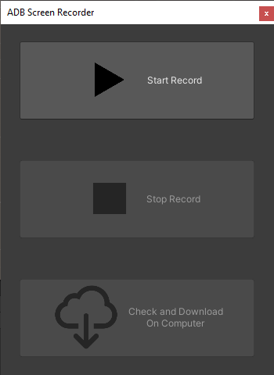

- Click “Start Record” button to start recording.

- Click “Stop Record” button to stop recording.

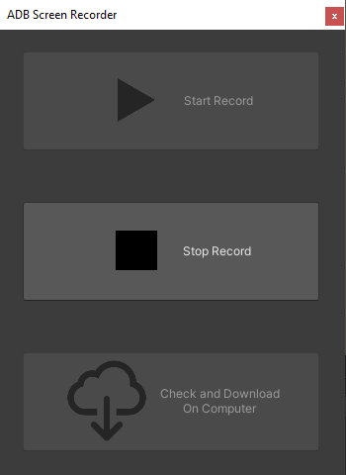

- After record saved successfully, you can download on computer by click “Check and Download On Computer”

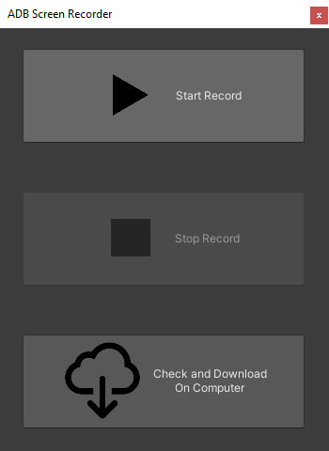

Support:
info@studiobillion.com

